**Shubhan Singh**

**2022300118**

**SE-Comps B/Batch C**

**7th February 2024**

**Scilab no.2: Matrix Operations**

**Program No.1** :- Extract the diagonal matrices of the 4x4 matrices given below:

A= $\left[\begin{matrix}12 & 22 & 32 & 68 \\ 42 & 52 & 62 & 77 \\ 11 & 21 & 31 & 84 \\ 24 & 55 & 66 & 10\end{matrix}\right]$

B= $\left[\begin{matrix}14 & 25 & 36 & 15 \\ 28 & 38 & 19 & 59 \\ 16 & 35 & 44 & 87 \\ 17 & 65 & 43 & 24\end{matrix}\right]$

**Code :-**

clc;

A=[12 22 32 68;42 52 62 77;11 21 31 84;24 55 66 10];

B=[14 25 36 15;27 38 19 59;16 35 44 87;17 65 43 24];

printf("A:");

disp(A);

printf("B:");

disp(B);

C=eye(4,4).*A;

printf("The diagonal matrix of A is:");

disp(C);

D=eye(4,4).*B;

printf("The diagonal matrix of B is:");

disp(D);

**Output :-**

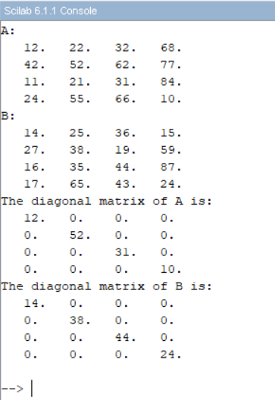

**Program No. 2:-** Extract the real and imaginary parts of matrix A, where:

A= $\left[\begin{aligned}1+3i 5 3+5i \\ 3+2i 5 7+8i \\ 9 7 99i\end{aligned}\right]$

**Code**:-

clc;

A=[1+%i*3 5 3+%i*5; 3+%i*2 5 7+%i*8;9 7 %i*99];

printf("The matrix A is:");

disp(A);

B=real(A);

C=imag(A);

printf("The real part of A is:");

disp(B);

printf("The imaginary part of A is:");

disp(C);

**Output** :-

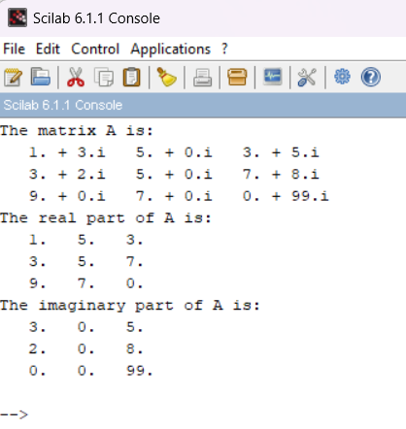

**Program No. 3 :-** Find the determinant, trace, inverse and trace of inverse of matrix A, where A is:

A= $\left[\begin{aligned}1 0 0 \\ 0 1 0 \\ 0 0 1\end{aligned}\right]$

**Code** :-

clc

A= eye(3, 3);

printf("A is: ");

disp(A);

printf("Determinant of A: ");

disp(det(A));

printf("Trace of A: ");

disp(trace(A));

printf("Inverse of A: ");

B= inv(A);

disp(B);

printf("Trace of Inverse of A: ");

disp(trace(B));

**Output** :-

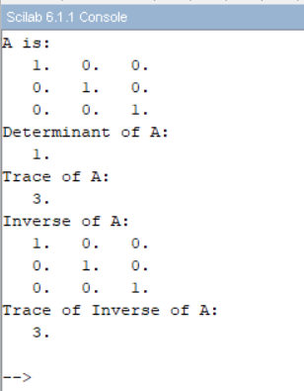

**Program no. 4** :- Output the 2nd row and 3rd column of the given 4x4 matrix using the matrix A.

A= $\left[\begin{matrix}12 & 22 & 32 & 68 \\ 42 & 52 & 62 & 77 \\ 11 & 21 & 31 & 84 \\ 24 & 55 & 66 & 10\end{matrix}\right]$

**Code** :-

clc;

A=[12 22 32 68;42 52 62 77;11 21 31 84;24 55 66 10];

printf("The amatrix A is:");

disp(A);

printf("The third column of A is:");

disp(A(:,3));

printf("The second row of A is:")

disp(A(2,:));

**Output** :-

**Program No. 5** :- Output the 8th element of given 4x4 matrices and also display the rank of the same matrices.

A= $\left[\begin{matrix}12 & 22 & 32 & 68 \\ 42 & 52 & 62 & 77 \\ 11 & 21 & 31 & 84 \\ 24 & 55 & 66 & 10\end{matrix}\right]$

B= $\left[\begin{matrix}14 & 25 & 36 & 15 \\ 28 & 38 & 19 & 59 \\ 16 & 35 & 44 & 87 \\ 17 & 65 & 43 & 24\end{matrix}\right]$

**Code** :-

clc;

A=[12 22 32 68;42 52 62 77;11 21 31 84;24 55 66 10];

B=[14 25 36 15;27 38 19 59;16 35 44 87;17 65 43 24];

printf("The matrix A is:");

disp(A);

printf("The matrix B is:");

disp(B);

printf("The eighth element of A is:");

disp(A(8));

printf("The eighth element of B is:");

disp(B(8));

printf("The rank of matrix A is:");

disp(rank(A));

printf("The rank of matrix B is:");

disp(rank(B));

**Output** :-

**Program no. 6** :- Input a random square matrix and extract its upper and lower triangular matrices. Take the sum and product of all the elements, rows and columns. Also. find the rank of the same matrix and diagonal matrix. If the determinant of the matrix is non-zero, also output the inverse.

**Code** :-

clc;

A=rand(4,4);

printf("The matrix A is:");

disp(A);

printf("The lower triangular matrix of A is:");

disp(tril(A));

printf("The upper triangular matrix of A is:");

disp(triu(A));

printf("The sum of all row elements of A is");

disp(sum(A,'r'));

printf("The sum of all column elements of A is");

disp(sum(A,'c'));

printf("The product of all row elements of A is");

disp(prod(A,'r'));

printf("The product of all column elements of A is");

disp(prod(A,'c'));

printf("The rank of A is:");

disp(rank(A));

printf("The determinant of A is:");

disp(det(A));

printf("The inverse of A is:");

disp(inv(A));

**Output** :-

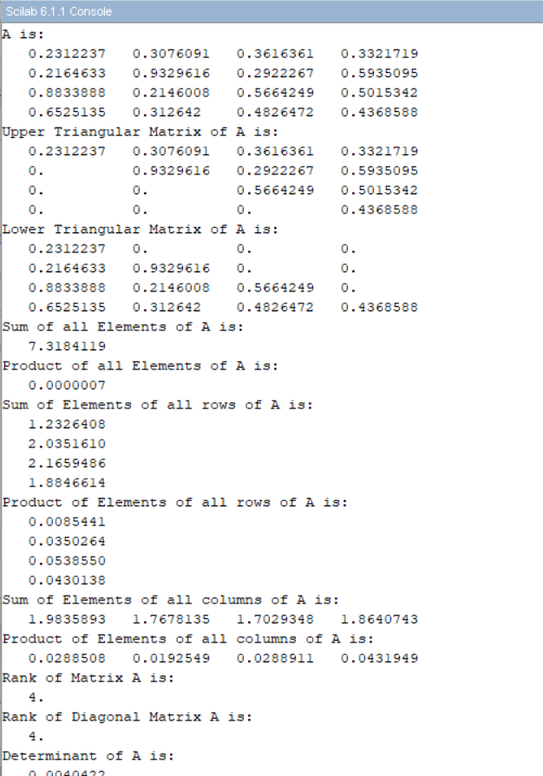

**Program No. 7** :- Extract the diagonal element of the given matrices and also output their conjugates.

A= $\left[\begin{matrix}12 & 22 & 32 & 68 \\ 42 & 52 & 62 & 77 \\ 11 & 21 & 31 & 84 \\ 24 & 55 & 66 & 10\end{matrix}\right]$

B= $\left[\begin{matrix}14 & 25 & 36 & 15 \\ 28 & 38 & 19 & 59 \\ 16 & 35 & 44 & 87 \\ 17 & 65 & 43 & 24\end{matrix}\right]$

**Code** :-

clc;

A= [12, 22, 32, 68; 42, 52, 62, 77; 11, 21, 31, 84; 24. 55. 66. 10];

B= [14, 25, 36, 15; 27, 38, 19, 59; 16, 35, 44, 24; 17, 65, 43, 24];

printf("A is: ");

disp(A);

printf("B is: ");

disp(B);

printf("Diagonal of A: ");

disp(diag(A));

printf("Diagonal of B: ");

disp(diag(B));

printf("Conjugate of A: ");

disp(conj(A));

printf("Conjugate of B: ");

disp(conj(B));

**Output** :-

